 | 
COUNCIL ASSESSMENT REPORT
HUNTER AND CENTRAL COAST REGIONAL PLANNING PANEL

PANEL REFERENCE & DA NUMBER | PPSHCC-190 – DA 16-2023-205-1
PROPOSAL | Alterations and Additions to Air Transport Facility - upgrades to the existing airfield
ADDRESS | 1 Williamtown Road, Williamtown  (LOT: 43 DP: 1045602  LOT: 201 DP:1091749)
APPLICANT | Newcastle Airport Pty Limited
OWNER | Commonwealth Government – Department of Defence leased by Newcastle Airport Pty Ltd
DA LODGEMENT DATE | 21 April 2023
APPLICATION TYPE | Development Application
REGIONALLY SIGNIFICANT CRITERIA | Clause 3, Schedule 6 of State Environmental Planning Policy (Planning Systems) 2021: Council related development over $5 million
CIV | $22,536,520 (including GST)
CLAUSE 4.6 REQUESTS | NIL
KEY SEPP/LEP | State Environmental Planning Policy (Biodiversity and Conservation) 2021  State Environmental Planning Policy (Planning Systems) 2021  State Environmental Planning Policy (Precincts— Regional) 2021  State Environmental Planning Policy (Resilience and Hazards) 2021  State Environmental Planning Policy (Transport and Infrastructure) 2021  Port Stephens Local Environmental Plan 2013
TOTAL & UNIQUE SUBMISSIONS KEY ISSUES IN SUBMISSIONS | NIL
DOCUMENTS SUBMITTED FOR CONSIDERATION | Attachment 1 – Recommended Conditions of Consent  Attachment 2 – Architectural Plans  Attachment 3 – Stormwater Management Report  Attachment 4 – Contamination Investigation  Attachment 5 – Cost Estimate Report  Attachment 6 – Flood Certificate  Attachment 7 – Ausgrid Comment  Attachment 8 – EPA Comment  Attachment 9 – Defence Comment  Attachment 10 – Hunter Water Comment
SPECIAL INFRASTRUCTURE CONTRIBUTIONS (S7.24) | NIL
RECOMMENDATION | Approval
DRAFT CONDITIONS TO APPLICANT | Yes
SCHEDULED MEETING DATE | 13 February 2024
PLAN VERSION | 16 October 2023 Version No H
PREPARED BY | Rean Lourens
DATE OF REPORT | 6 February 2024

EXECUTIVE SUMMARY

The development application (DA 16-2023-205-1) seeks consent for alterations and additions to an existing air transport facility.

The proposed development will be undertaken by Newcastle Airport Pty Ltd (NAPL) to support an upgrade of the existing aircraft taxiway to allow for larger, international flights to be serviced at Newcastle Airport. This will involve upgrades to the existing airfield including Code E Apron design works, as well as Code C taxi lane realignment and apron extension, and the construction of a new storage area for general service equipment.

After discussions with the Department of Defence, the applicant requested an amendment to the proposal under Clause 37 of the EP&A Regulation 2021 on 29 November 2023 to reduce the extent of the apron extensions and to remove staging of the proposal.

The subject site is known as the Newcastle Airport and comprises of approximately 20.7ha of irregularly shaped land. The site has access to Nelson Bay Road in the south via Williamtown Drive.

Existing development on the site consists of carparking (south and west), an aircraft terminal (northeast) and runway / aprons (east). The RAAF Base Williamtown is located further east of the runway, while the remaining land surrounding the site is utilised for rural residential activities.

The site is zoned SP2 – Defence / Air Transport Facility and SP2 – Defence pursuant to Clause 2.2 of the Port Stephens Local Environmental Plan 2013 (PSLEP 2013). The land use is defined as an Air Transport Facility that is permissible under the provisions of the SP2 – Defence / Air Transport Facility. However, the works proposed within the SP2 Defence zone will rely on permissibility via State Environmental Planning Policy (Transport and Infrastructure) 2021.

The principal planning controls relevant to the proposal include Port Stephens Local Environmental Plan 2013 (PSLEP 2013) and the Port Stephens Development Control Plan 2014 (PSDCP 2014). The proposal is consistent with the relevant provisions of these planning controls.

There are no concurrence requirements from agencies for the proposal and the application is not integrated development pursuant to Section 4.46 of the Environmental Planning and Assessment Act 1979 (EP&A Act).

The following external referrals were undertaken:
- Ausgrid
- Environmental Protection Authority
- NSW Regional Growth
- Federal Department of Defence
- Hunter Water

The application was placed on public exhibition from 9 May 2023 to 6 June 2023, with no submissions received during this period. Renotification of the proposal, subsequent to the lodgement of the Clause 37 amendments, was not deemed necessary as the amendments were minor in nature.

The application was referred to the Hunter and Central Coast Planning Panel (‘the Panel’) as the development is ‘regionally significant development’, pursuant to Section 2.19(1) and Clause 3 of Schedule 6 of State Environmental Planning Policy (Planning Systems) 2021 as the proposal is Council development with a CIV over $5 million.

A briefing was held with the Panel on 11 July 2023 where key issues were discussed, including zoning and permissibility of the proposed development.

The key issues associated with the proposal included:

- The interrelationship of the proposal with the airports broader intentions of expansion to offer international flights, including any associated approvals.
- Clarification was sought on the permissibility of the proposed development located within the SP2 Defence zone that is not permissible with consent under the PSLEP 2013.
- Stormwater drainage and potential impacts to Defence land.
- Contamination, including the presence of PFAS.

Following a detailed assessment of the proposal, pursuant to Section 4.15(1) of the EP&A Act, DA 16-2023-205-1 is recommended for approval subject to the conditions contained in Attachment A of this report.

- THE SITE AND LOCALITY

  - The Site

The subject site is located at 1 Williamtown Road, Williamtown and is legally identified as Lot 43 DP1045602 (Newcastle Airport) and Lot 201 DP1091749 (RAAF Base Williamtown and runway). The site is irregular in shape, as shown in Figure 1 below. The site is predominately flat in topography and is positioned within the Newcastle Airport precinct that provides a range of tourist, commercial, aviation and defence uses. As shown in Figure 1, the subject site is located to the northeast of the Newcastle Airport terminal (operated by NAPL) that shares its runway with the RAAF Base Williamtown to the east.

The site is linked into the greater road network via Williamtown Drive, connecting it directly to Nelson Bay Road, which provides access to Nelson Bay and Tilligerry Peninsula in the east, Newcastle in the south and Medowie to the north.

The site is subject to a number of environmental constraints (as mapped on Councils' GIS system) including:

- Weed Infestations
- Bushfire Prone – Vegetation Buffer
- Koala Habitat – Preferred, 50m Buffer over Cleared and Link over Cleared
- Acid Sulfate Soils – Class 3 and 4
- 16-2022-756-1
- Assessment Report: DA16-2022-756-1 4 April 2023 Page 5
- Biodiversity Values map
- ANEF – 35-40 and 40+
- Height Trigger Map – Defence Boundaries
- Bird Strike – Group C
- Extraneous Lighting (CASA) – 6km radius, zone D and zone C
- Extraneous Lighting (DOD) – Restrictions on the amount of upward light emitted
- Engine Run Up Facility
- Hunter Water Special Area
- PFAS Management Area – Williamtown RAAF Base
- Flood Planning (PMF)
- Drinking Water Catchment.

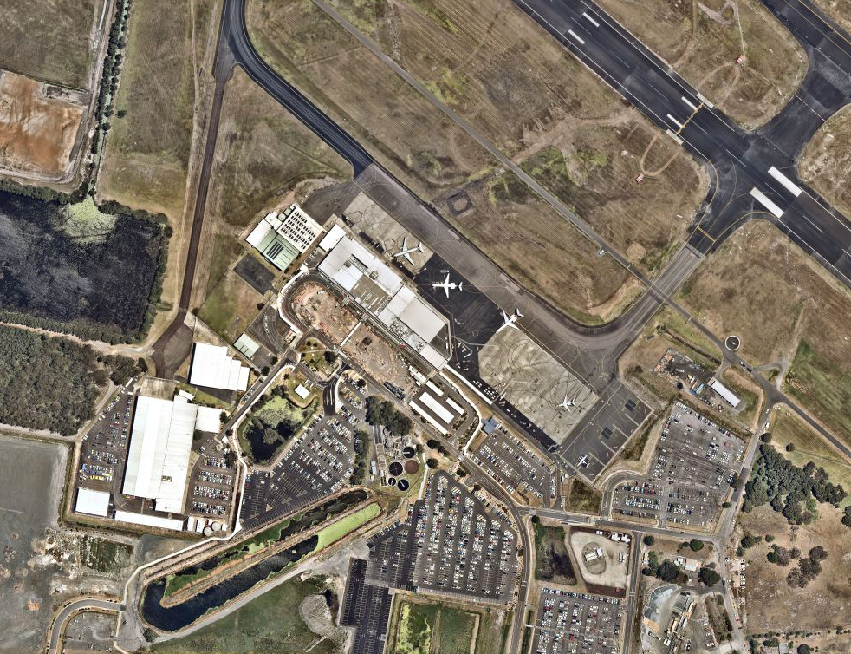
Figure 1: Aerial image of site area

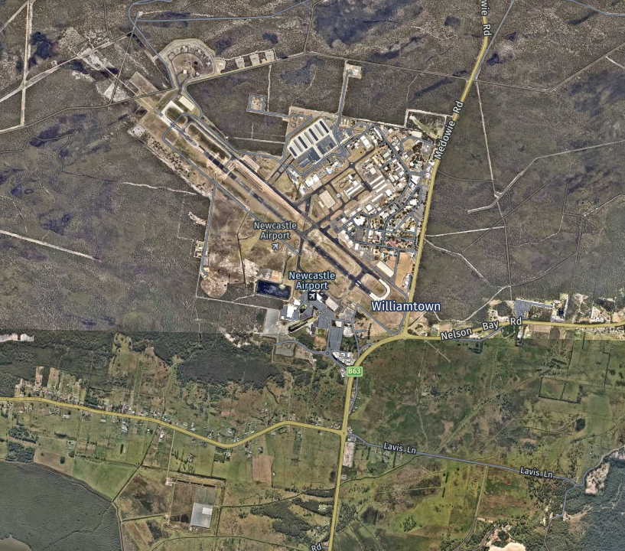
Figure 2: Aerial image of the wider area

  - Site Inspection

A site inspection was carried out on 29 June 2023. The subject site can be seen in the photos below:

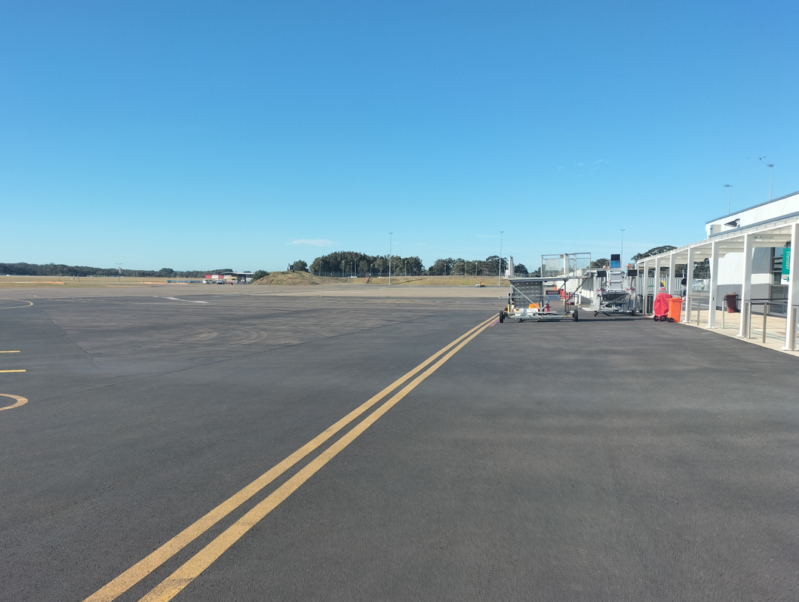
Figure 3: View across the apron towards the southeast

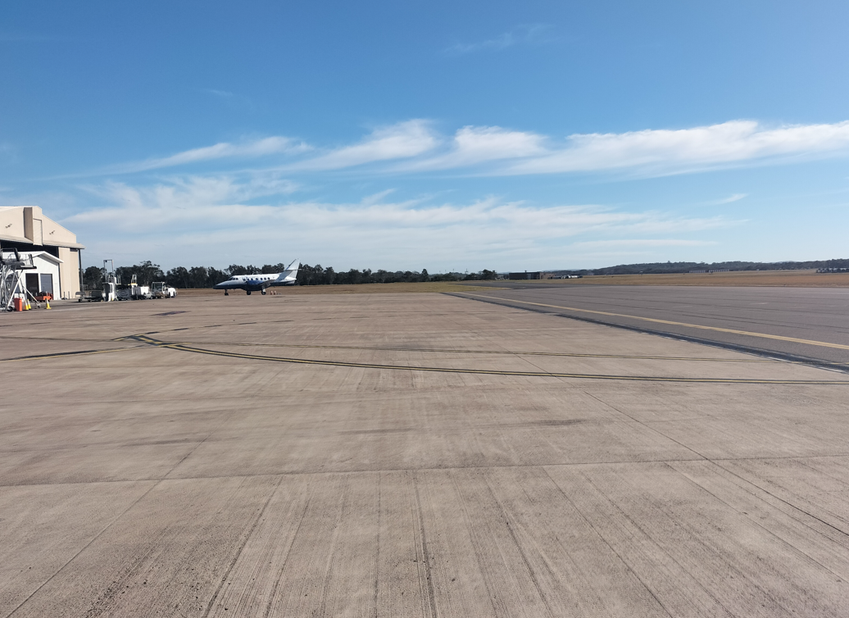
Figure 4: View across the apron towards the northwest

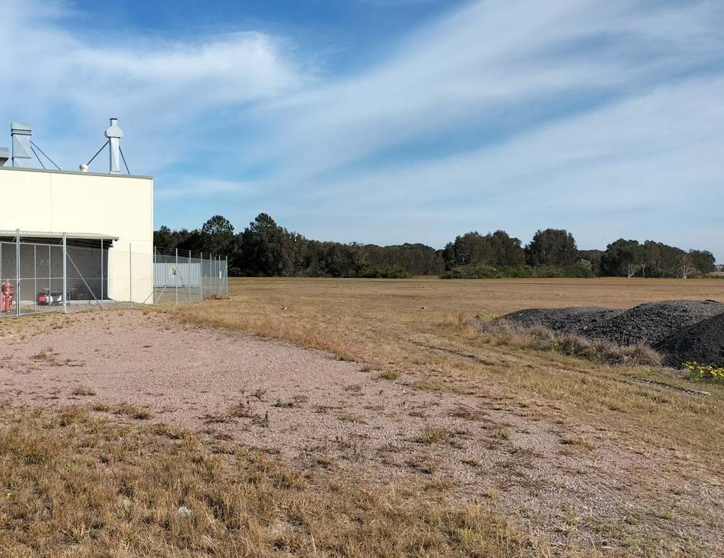
Figure 5: View towards the southwest across the proposed service area

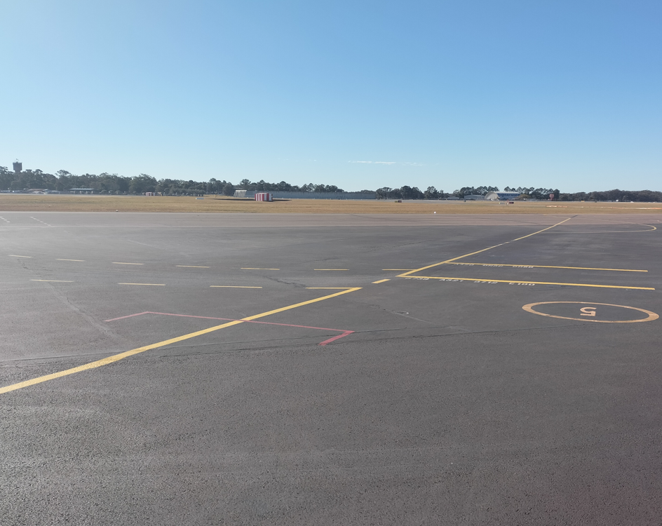
Figure 6: View across the apron and runway toward Williamtown RAAF Base in the northwest.

- THE PROPOSAL AND BACKGROUND

  - The Proposal

The development application (DA 16-2023-205-1) seeks consent for alterations and additions to an existing air transport facility.

The proposed development would be undertaken by NAPL to support the upgrade of existing aircraft taxiway to allow for larger, international flights to be serviced at Newcastle Airport. This will involve upgrades to the existing airfield including Code E Apron design works, as well as Code C taxi lane realignment and apron extension, and the construction of a new storage area for general service equipment.

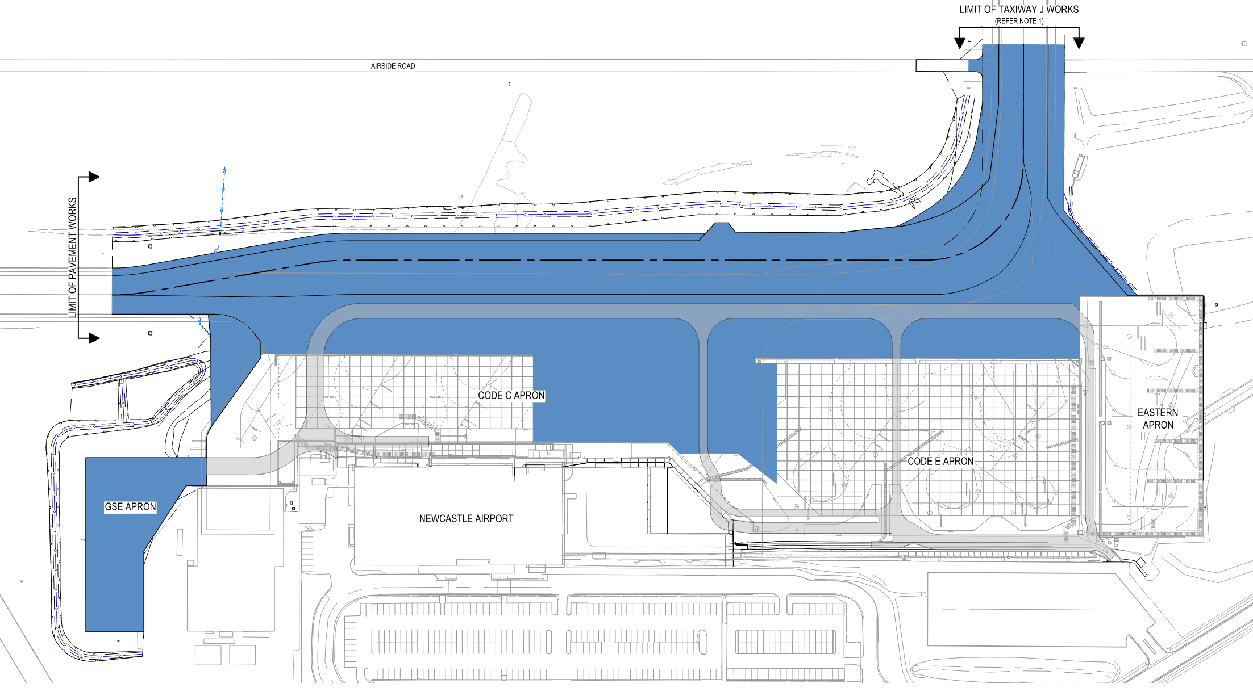
Figure 7: Footprint of the proposed apron and storage extensions.

Proposed works include:

- Demolition and excavation of the existing pavement and excavation of existing uncontrolled soils in works areas
- Replacement of special select fill material to support Code E aircraft
- Construction of new pavement, and relocation and redevelopment of existing stormwater drainage infrastructure
- Installation of new aeronautical ground lights (AGL), including taxiway centreline lights, apron edge lights, new pit, and duct, and new and extension of existing cabling
- Relocation of existing services, including fibre optic and data cabling
- Construction of a new storage area for general service equipment (GSE) to the immediate west of the terminal, including lighting and electric charging infrastructure provisions
- Refurbishment of existing Code E apron surface
- Staging of the application over two (2) stages.

After discussions with the Department of Defence, the applicant requested an amendment to the proposal under Clause 37 of the EP&A Regulation 2021 on 29 November 2023 to reduce the extent of the apron extensions and to remove staging of the proposal. It is understood that the changes were necessary to satisfy the Department of Defence that stormwater from the additional hardstand would not have a significant impact on the operation of the runway.

  - Background

The development application was lodged on 24 April 2023. A chronology of the development application since lodgement is outlined below including the Panel’s involvement (briefings, deferrals etc) with the application:

Table 2: Chronology of the DA
Date | Event
24 April 2023 | DA lodged
28 April 2023 | DA referred to external agencies
5 May 2023 | Request for information relating to the Hunter Water comments were issued
9 May 2023 | Exhibition of the application (28 days)
9 June 2023 | Response received from application to the Hunter Water comments
16 June 2023 | Request for Information from Council to applicant
11 July 2023 | Panel briefing
20 July 2023 | Response received from application to the issues raised by Council and the Panel
29 November 2023 | Applicant lodged amendments to the proposal under Clause 37 of the Environmental Planning and Assessment Regulations 2021.

  - Site History

The site has historically been used as the RAAF Base Williamtown and the Newcastle Airport.

NAPL has been in the process of establishing the capacity to allow for international air travel from the Newcastle Airport. This includes the following:

- Runway Upgrade

The Federal Government has funding to upgrade the RAAF Base Williamtown runway that will result in the widening of the runway to accommodate longer range domestic and international passenger services, as well as significantly increased large freight capabilities to benefit local exporters. The work will be carried out alongside RAAF’s scheduled runway maintenance at the Williamtown RAAF Base. Approval for the runway widening works is issued by the Commonwealth Government.

- International Terminal

The Newcastle Airport Terminal upgrade involves significant alterations and additions to the airport's existing terminal building.

Several recent applications have been lodged over the subject land for the expansion of the airport terminal. These include:

DA Number | Proposed Works | Date of Approval
16-2023-78-1 | Installation of baggage handling system at airport | 27 June 2023
16-2022-855-1 | Carpark extension - construction of 314 new parking spaces and conversion of 756 airport parking spaces for use as part of the Astra Aerolab | 23 May 2023
16-2008-940-6 | S4.55(1A) Modification to approved alterations and additions to Newcastle airport terminal – amend terminal building design | 30 March 2023
16-2008-940-1 to 5 | Alterations and Additions to Airport Terminal | 1 April 2013 to February 2023

The upgrade projects are supported by Federal Government provision of funding, to upgrade the international passenger terminal. The alterations and additions to the terminal building are currently under construction and estimated to be completed in 2025.

- Enabling Works

Various enabling works have been completed or planned to support the new passenger terminal. These include the new Premium Car Park (DA 16-2022-428-1), the extension of existing car parks (DA 16-2021-1153-1) and a new high voltage Substation (DA 16-2023-61-1).

- Newcastle Airport Operations

NAPL’s operations are regulated by an agreement with the Department of Defence known as an “Operating Deed” which complements the lease agreement NAPL holds which allows for the use of Defence land for commercial airport operations. The proposed development will facilitate access for larger passenger aircraft (Code E) to the Newcastle Airport Terminal, however the proposed operations will continue to comply with the conditions stipulated in the Operating Deed between NAPL and the Aerodrome owner/operator Department of Defence which include details of operating hours and flight numbers. These are not proposed to change as a result of the proposed development.

The terminal has also been upgraded to provide for separate customs and immigration processing that is staffed by the Australian Border Force.

The apron upgrade works included in this application will provide for wide body aircraft to further expand the passenger and cargo services that can be accepted at the Newcastle Airport. The proposed works is therefore considered to be the last stage in preparing the airport for longer range international flights.

- STATUTORY CONSIDERATIONS

When determining a development application, the consent authority must take into consideration the matters outlined in Section 4.15(1) of the Environmental Planning and Assessment Act 1979 (‘EP&A Act’). These matters as are of relevance to the development application include the following:

- the provisions of any environmental planning instrument, proposed instrument, development control plan, planning agreement and the regulations
(i) any environmental planning instrument, and
(ii) any proposed instrument that is or has been the subject of public consultation under this Act and that has been notified to the consent authority (unless the Planning Secretary has notified the consent authority that the making of the proposed instrument has been deferred indefinitely or has not been approved), and
(iii) any development control plan, and
(iiia) any planning agreement that has been entered into under section 7.4, or any draft planning agreement that a developer has offered to enter into under section 7.4, and
(iv) the regulations (to the extent that they prescribe matters for the purposes of this paragraph),
that apply to the land to which the development application relates,
- the likely impacts of that development, including environmental impacts on both the natural and built environments, and social and economic impacts in the locality,
- the suitability of the site for the development,
- any submissions made in accordance with this Act or the regulations,
- the public interest.

These matters are further considered below.

It is noted that the proposal is not considered to be:

- Integrated Development (s4.46)
- Designated Development (s4.10)
- Crown DA (s4.33) - written agreement from the Crown to the proposed conditions of consent must be provided.

3.1 Other Statutory considerations - Section 4.14 – Consultation and development consent (certain bushfire prone land)

Section 4.14(1) provides that development consent cannot be granted for the carrying out of development for any purpose (other than a subdivision of land that could lawfully be used for residential or rural residential purposes or development for a special fire protection purpose) on bush fire prone land (being land for the time being recorded as bush fire prone land on a relevant map certified under section 10.3(2)) unless the consent authority—

- is satisfied that the development conforms to the specifications and requirements of the version (as prescribed by the regulations) of the document entitled Planning for Bush Fire Protection prepared by the NSW Rural Fire Service in co-operation with the Department (or, if another document is prescribed by the regulations for the purposes of this paragraph, that document) that are relevant to the development (the relevant specifications and requirements), or
- has been provided with a certificate by a person who is recognised by the NSW Rural Fire Service as a qualified consultant in bush fire risk assessment stating that the development conforms to the relevant specifications and requirements.

The areas surrounding the Newcastle Airport and RAAF Base Williamtown subject site is identified as bushfire prone, however, the subject area is located at least 200m from the closest bushfire prone land.

The proposed works will therefore not require any specific bushfire upgrades as required by Planning for Bushfire Protection 2019.

  - Environmental Planning Instruments, proposed instrument, development control plan, planning agreement and the regulations

The relevant environmental planning instruments, proposed instruments, development control plans, planning agreements and the matters for consideration under the Regulation are considered below.

- Section 4.15(1)(a)(i) - Provisions of Environmental Planning Instruments

The following Environmental Planning Instruments are relevant to this application:

- State Environmental Planning Policy (Biodiversity and Conservation) 2021
- State Environmental Planning Policy (Planning Systems) 2021
- State Environmental Planning Policy (Resilience and Hazards) 2021
- State Environmental Planning Policy (Transport and Infrastructure) 2021
- State Environmental Planning Policy (Industry and Employment) 2021
- Port Stephens Local Environmental Plan 2013 (PSLEP 2013)

A summary of the key matters for consideration arising from these State Environmental Planning Policies are outlined in Table 3 and considered in more detail below.

Table 3: Summary of Applicable Environmental Planning Instruments
EPI | Matters for Consideration | Comply (Y/N)
SEPP (Biodiversity and Conservation) 2021 | Chapter 4 – Koala Habitat Protection 2021  The site is not a core koala habitat and the site does not contain any habitat protected by this policy.  No vegetation will be removed as part of the proposal. | Y
SEPP Planning Policy (Planning Systems) 2021 | Chapter 2: State and Regional Development  Section 2.19(1) declares the proposal regionally significant development pursuant to Clause 3 of Schedule 6 as it comprises Council related development over $5 million | Y
SEPP (Resilience & Hazards) | Chapter 3: Hazardous and Offensive Development  The proposed development is not considered to be a potentially hazardous industry.  Chapter 4: Remediation of Land  Section 4.6 - Contamination and remediation has been considered in the Contamination Status Report prepared by GHD and the site is considered suitable for the proposed use with regards to contamination. | Y
SEPP (Transport and Infrastructure) 2021 | Chapter 2: Infrastructure  Section 2.48(2) (Determination of development applications – other development) – electricity transmission – the proposal is satisfactory subject to conditions endorsed by the electricity supply authority (Ausgrid). | Y
SEPP (Industry and Employment) 2021 | Chapter 3: Advertisement and signage  No issues identified in accordance with assessment criteria under Schedule 5 of this SEPP. | Y
PSLEP 2013 | - Clause 2.7 – The application included the demolition of the existing apron and therefore requires development consent.  - Clause 4.3 – The development is below the maximum building height limits of the site.  - Clause 5.10 – The development was assessed by Council’s Heritage consultant, and it was concluded that the proposal will not alter the heritage character of the area.  - Clause 5.21 – Flood impacts have been considered to meet the provisions under Clause 5.21.  - Clause 7.1 – The potential impact from Acid Sulfate Soils have been considered to meet the provisions under Clause 7.1.  - Clause 7.2 – Earthworks have been considered to meet the provisions under Clause 7.2(3).  - Clause 7.4 – Airspace Operations  - Clause 7.5 – Development in areas subject to aircraft noise  - Clause 7.6 – All essential services are available to the site under Clause 7.6.  - Clause 7.8 – The potential impacts on the Hunter Water catchment was assessed under the provisions of Clause 7.8. | Y

State Environmental Planning Policy (Biodiversity and Conservation) 2021

Chapter 4: Koala Habitat Protection 2021

This chapter aims to encourage the conservation and management of areas of natural vegetation that provide habitat for koalas to support a permanent free-living population over their present range and reverse the current trend of koala population decline. The provisions of the SEPP apply to development applications relating to land within Port Stephens Council and:

- Where there is an approved Koala Plan of Management for the land, the development application must be consistent with the approved koala plan of management that applies to the land.

- Where there is no approved Koala Plan of Management for the land,
- if the land is identified on the Koala Development Application Map, and
- has an area of more than 1 hectare, or
- has, together with any adjoining land in the same ownership, an area of more than 1 hectare, whether or not the development application applies to the whole, or only part, of the land.

The Comprehensive Koala Plan of Management (CKPoM) applies to the land and therefore, the proposal must be consistent with the CKPoM. The site is largely mapped as containing “link over cleared” koala habitat. Areas mapped as “Preferred Koala Habitat” and “50m Buffer over Cleared” also exist around the perimeter of the site.

The site was cleared of vegetation as a result of works associated with establishment of the Newcastle Airport, and no further clearing is required to facilitate the proposed development.

Given there are no clearing works proposed, the development is consistent with the Port Stephens Comprehensive Koala Plan of Management which constitutes compliance with Chapter 4 of State Environmental Planning Policy (SEPP) (Biodiversity & Conservation) 2021.

State Environmental Planning Policy (Planning Systems) 2021

The proposal is regionally significant development pursuant to Section 2.19(1) as it satisfies the criteria in Clause 3 of Schedule 6 of the Planning Systems SEPP, being Council related development with a capital investment value over $5 million. Accordingly, the Hunter and Central Coast Regional Planning Panel (HCCRPP) is the consent authority for the application. The proposal is consistent with this Policy.

State Environmental Planning Policy (Precincts—Regional) 2021

At lodgement, the site was located within the draft Williamtown Special Activation Precinct. However, a review was undertaken by the NSW State Government to ensure capital expenditure delivers maximum benefit to citizens of NSW and is aligned with the Government’s strategic objectives and priorities. Following consideration of the review findings, the NSW Government has decided not to proceed with this project.

The Policy therefore no longer applies to the proposal.

State Environmental Planning Policy (Resilience and Hazards) 2021

Chapter 4: Remediation of Land

The provisions of Chapter 4 of State Environmental Planning Policy (Resilience and Hazards) 2021 (‘the Resilience and Hazards SEPP’) have been considered in the assessment of the development application. Section 4.6 of Resilience and Hazards SEPP requires a consent authority to consider whether the land is contaminated, and if the land is contaminated, it is satisfied that the land is suitable in its contaminated state (or will be suitable, after remediation) for the purpose for which the development is proposed to be carried out.

A Contamination Investigation was submitted with the application which found Contaminants of Potential Concern (COPC), which included Polycyclic Aromatic Hydrocarbons (PAH) and Per-and Polyfluoroalkyl Substances (PFAS) contamination.

It is noted that PFAS contamination in the region is managed under the RAAF Base Williamtown PFAS Management Area Plan (PMAP). The report noted that the management procedures in the PMAP would be relevant to users on site, whilst a variety of mitigation measures will be incorporated into a Soil and Water Management Plan. Recommended conditions from the Environmental Protection Agency (EPA), have also been issued to address PFAS contamination.

The PAH contamination has generally been classified as general solid waste and can be disposed of via land fill. However, the contamination identified at one (1) test pit was found to potentially exceed these requirements and may need to be classified as Restricted Solid Waste. Further testing will be required during the earthworks stage of the project.

The recommendations from the EPA and Council’s Environmental Health Section have been included in the conditions contained in Attachment 1.

Given the above, the proposal is considered to satisfy the requirements of Chapter 4 of this SEPP.

State Environmental Planning Policy (Transport and Infrastructure) 2021

Chapter 2: Infrastructure

This policy provides for additional permissible uses for the provision of private and public infrastructure in NSW.

It is noted that most of the proposed development is permissible with consent under the provisions of the PSLEP 2013. However, the new storage area for general service equipment is located on land zoned SP2 (Defence) and is not permissible under the PSLEP 2013 zone provisions.

Clause 2.25 of the SEPP states that development for passenger transport facilities can be undertaken with consent on land within the boundaries of an existing air transport facility. It is considered that the new storage area falls within the curtilage of the existing airport and will be ancillary to the existing airport operations. The new storage facility is therefore permissible with consent on the subject land.

Clause 2.48(2) of this policy requires consultation with the relevant electricity authority, where development is proposed in proximity to electrical infrastructure. Referral correspondence with Ausgrid confirms the proposal can be safely undertaken with respect to nearby electricity assets.

Clause 2.122 of this policy requires that where development is considered ‘traffic generating’ it must be referred to Transport for NSW (TfNSW). As the proposal will not increase traffic, it is considered that this section of the Policy does not apply.

Port Stephens Local Environmental Plan 2013

The relevant local environmental plan applying to the site is the PSLEP 2013.

The aims of the LEP are:

- to cultivate a sense of place that promotes community well-being and quality of life,
- to provide for a diverse and compatible mix of land uses,
- to protect and conserve environmental values,
- to facilitate economic growth that contributes to long-term employment,
- to provide opportunities for housing choice and support services tailored to the needs of the community,
- to conserve and respect the heritage and cultural values of the natural and built environments,
- to promote an integrated approach to the provision of infrastructure and transport
services,
- to protect and promote the use and development of land for arts and cultural activity,
including music and other performance arts.

The proposal is consistent with these aims as the proposal contributes to the diverse land uses within a compatible zoning and will contribute to long term employment.

Clause 2.3 Zone objectives and Land Use Table

The site is located within the SP2 – Defence / Air Transport Facility Zone and SP2 – Defence, pursuant to Clause 2.2 of the PSLEP 2013.
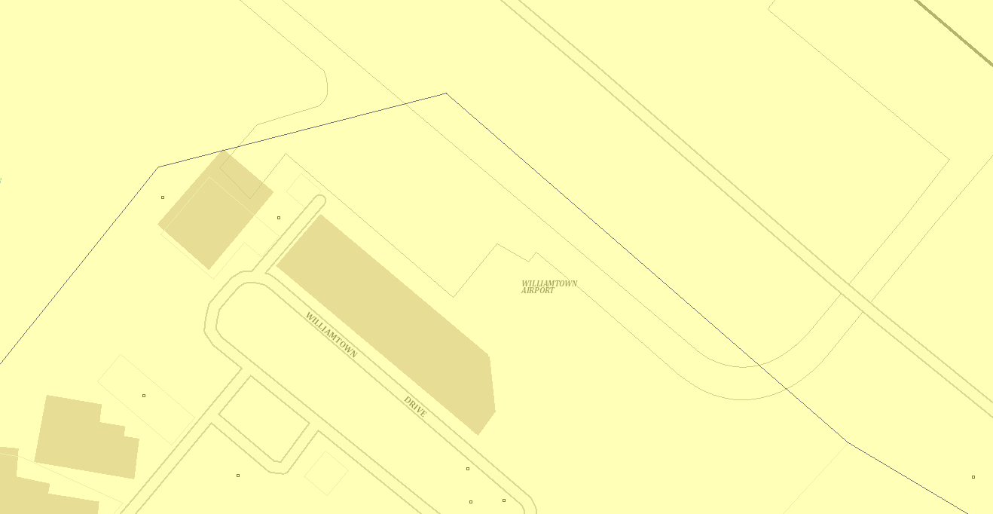
SP2 – Defence
SP2 – Defence / Air Transport Facility
Figure 8: Zoning Map

The zone objectives include the following (pursuant to the Land Use Table in Clause 2.3):

- To provide for infrastructure and related uses.
- To prevent development that is not compatible with or that may detract from the
- provision of infrastructure.

The proposal is considered to be consistent with these zone objectives for the following reasons:

- The proposed development is compatible with surrounding airport and RAAF base infrastructure and operations;
- The development provides for upgraded infrastructure to service the adjoining existing Newcastle Airport facility.

Air Transport Facilities are a permissible land use under the SP2 – Air Transport Facility zoning. As stated previously in the report, the proposed stage area for general service equipment is located in land zoned SP2 – Defence and is therefore not permissible under the PSLEP 2013 provisions. Permissibility for this component of the development is provided through the provisions of Clause 2.25 of the SEPP (Transport and Infrastructure) 2021.
Clause 2.7 – Demolition requires development consent

The proposed development includes minor demolition activities, associated with the alterations and additions to the aircraft hangar and ancillary buildings. This demolition cannot be carried out as exempt or complying development and requires development consent.
The applicant provided a Demolition Plan and conditions of consent have been recommended to manage demolition works.

Section 5.10 Heritage conservation

The objectives of this clause are to conserve environmental heritage, heritage items and
conservation areas, archaeological sites and Aboriginal sites and objects of heritage
significance.

The site is not listed as locally significant under Schedule 5 of the PSLEP 2013 or State Heritage Register. However, the RAAF Base Williamtown is listed under the Commonwealth Heritage List as having heritage significance. Council’s Heritage consultant reviewed the potential impacts and found that the proposed apron works will not alter the heritage character of the RAAF Base Williamtown.

An AHIMS search did not reveal any Aboriginal sites within the development footprint. The site has been subject to previous disturbance from its historical land uses. The proposal is therefore considered appropriate from a heritage perspective.

Clause 5.21 – Flood planning

The objectives of this clause are to minimise flood risk to life and property and avoid significant adverse impacts on flood behaviour and the environment, while allowing development on land that is compatible with the flood hazard.

The site is identified as flood prone on Council’s flood mapping.

The applicant provided a Flood Impact Assessment (prepared by GHD, dated 21 March 2023) that modelled the flood characteristics of the site and assessed the potential flood impacts resulting from the proposal. A further Flood Impact Assessment (prepared by Northrop Engineering, dated 27 November 2023) was prepared to address the amended design.

The later Flood Impact Assessment stated that the following flood mitigation works will be undertaken as part of the proposal:

- Widening (approximately 8m to 15m wide) the proposed western swale and extending it approximately 16m upstream and downstream. This will increase flood storage capacity in the area adjacent to the western apron fill.
- Installing an additional pit (0.9m x 0.9m grated) and 2 x 0.3m pipes directly connected to the approved rectangular concrete channel. This will increase discharge from the flood storage zone adjacent to the western apron fill to the downstream channels and detention basin.

Council’s Flood engineers assessed the potential impacts and proposed mitigation measures and concluded that the flood impact assessment satisfactorily demonstrates a negligible/non-detrimental impact on the wider airport precinct.

On this basis, risk to property and life from flooding is adequately managed and the proposal is consistent with the requirements of Clause 5.21.
Clause 7.1 – Acid Sulfate Soils

The objective of this clause is to ensure that development does not disturb, expose, or drain Acid Sulfate Soils (ASS) and cause environmental damage. The site is mapped as Class 4 Acid Sulfate Soils and as such works exceeding 2 metres below natural ground surface Australian Height Datum (AHD) is considered a potential environmental risk.

The applicant provided an Acid Sulfate Soils Management Plan (Ref. NEW23P-0065-AF, prepared by Qualtest, dated 16/02/2024) that addressed the potential for the exposure of acid sulfate spoils and recommended management procedure if ASS were encountered.

The assessment found that previous investigations did not identify ASS or the characteristics of soils that are prone to the formation of ASS.

However, as no specific testing was undertaken, the assessment recommended the following management procedures:

- Monitoring of soil excavation to identify any potential ASS;
- Testing of any potential ASS;
- Treatment of any contaminated soils
- Reuse of treated soils onsite or the safe offsite disposal.

A condition of consent has been included in the draft consent to ensure the recommendations of the Acid Sulfate Soils Management Plan are implemented during soil excavation.

Accordingly, the proposed development is considered to be satisfactory in regard to the management of acid sulfate soils.

Clause 7.2 – Earthworks

The objectives of Clause 7.2 are to ensure that earthworks for which development consent is required will not have a detrimental impact on environmental functions and processes,
neighbouring uses, cultural or heritage items or features of the surrounding land.

The additional excavation associated with the apron extension will be relatively minor as the void left by the demolition of the existing hardstand is at a depth of approximately 1.0m. The earthworks are therefore considered compliant with the PSLEP provisions.

Clause 7.4 – Airspace operations

The objectives of Clause 7.4 are to provide for the effective and ongoing operation of the RAAF Base Williamtown Airport by ensuring that such operation is not compromised by proposed development that penetrates the Limitation or Operations Surface for the airport.

The subject site is located adjacent to the main runway at the RAAF Base Williamtown and falls within the ‘Obstacle Limitation (OLS), Operations Surface Map’ and ‘Extraneous Lighting Map’. The application was referred to the Department of Defence for comment, who raised no objection. Advice was given to Council within the referral which has been considered in the assessment.

Clause 7.5 – Development in areas subject to aircraft noise

The objectives of Clause 7.5 are to prevent certain noise sensitive developments from being located near the RAAF Base Williamtown Airport and its flight paths so that development does not hinder or have any other adverse impacts on the ongoing, safe and efficient operation of the airport.

Although the proposal is located within the 30-35 and 40+ Australian Noise Exposure Forecast (ANEF) contours for the RAAF Base Williamtown, the proposal does not introduce any sensitive land uses that would be adversely impacted by aircraft noise and therefore this clause does not apply.

Clause 7.6 – Essential services

This clause provides that consent must not be granted unless the consent authority is satisfied that services that are essential for the development are available or that adequate arrangements have been made to make them available.

The site is already connected to all relevant services and its electrical infrastructure will be upgraded upon completion of the works. Conditions can be included to ensure that essential services are available at the completion of the works.

Accordingly, it is considered the proposed development satisfies this clause as adequate arrangements have been made to service the site.

Clause 7.8 – Drinking water catchments

The proposed development is located within a drinking water catchment and accordingly the requirements of this clause apply. The subject development has been designed to avoid negative impacts on the quality and quantity of water entering the drinking water storage (Tomago Sandbeds Special Area).

The application was referred to Hunter Water Corporation (HWC) in accordance with Section 51 of the Hunter Water Act 1991. In response, HWC provided conditions of consent to manage water quality should the application be approved.
The proposal is considered to be consistent with the PSLEP.

- Section 4.15 (1)(a)(ii) - Provisions of any Proposed Instruments

Proposed instruments which have been the subject of public consultation under the EP&A Act, and are relevant to the proposal, include the Draft Remediation of Land SEPP.

These proposed instruments are considered below:

Remediation of Land State Environmental Planning Policy

The proposed Remediation of Land SEPP is intended to repeal and replace Chapter 4 of SEPP Resilience and Hazards 2021. The draft SEPP, which was exhibited from 25 January to 13 April 2018, is currently under consideration.

The proposed SEPP seeks to provide a state-wide planning framework to guide the remediation of land, including outlining provisions that require consent authorities to consider the potential for land to be contaminated when determining development applications; clearly lists remediation works that require development consent; and introduces certification and operational requirements for remediation works that may be carried out without development consent.

Consideration has been given to the suitability of the site with respect to potential land contamination under SEPP Resilience and Hazards 2021 – Chapter 4 elsewhere within this report. The subject site has been identified as suitable for the proposed development and further investigation in respect to contamination is not warranted in this instance.

- Section 4.15(1)(a)(iii) - Provisions of any Development Control Plan

The following sections of the Port Stephens Development Control Plan 2014 (DCP) are relevant to the proposal:

Section B1 – Tree Management

No trees are proposed for clearing and therefore this chapter does not apply. All proposed works are to take place on already transformed surfaces.

Section B2 – Natural Resources
This chapter applies to development located within 500m of environmentally sensitive areas, development that contains koala habitat, noxious weeds or development that is seeking to use biodiversity credits.

The site is heavily disturbed, with all proposed works to be undertaken on already transformed surfaces. As such, the development will not result in significant ecological impacts, with specialist reports on biodiversity impacts not warranted. Despite the development occurring within 500m of preferred koala habitat, no koala feed trees or corridors will be impacted as part of the proposal. Accordingly, the proposed development complies with the performance criteria listed in Appendix 4 of the Port Stephens CKPOM. On this basis, the proposal is consistent with the requirements of this chapter.

Chapter B3 – Environmental Management

Chapter B3 contains provisions relating to noise, ASS and earthworks and have been assessed below.

Noise

The site is currently utilised for air transport purposes, and it is not expected that the proposed works will increase noise generation after the completion of works. There will be a temporary increase in noise from construction activities which will not make a significant impact on ambient noise due to the proximity to the RAAF Williamtown / Newcastle Airport runway areas.

Acid Sulfate Soils

The provisions of this chapter aim to ensure that development does not disturb, expose, or drain Acid Sulfate Soils and cause environmental damage. The site is mapped as Class 4 Acid Sulfate Soils and as such, works exceeding 2 metres below natural ground surface Australian Height Datum (AHD) is considered a potential environmental risk. No works are proposed below 1.3m AHD, therefore an Acid Sulfate Soils Management Plan is not necessary to accompany the application.

Any potential impacts as a result of the construction phase will be temporary and will be managed and mitigated by appropriate standard measures.

Earthworks

The additional excavation associated with the apron extension will be relatively minor as the void left by the demolition of the existing hardstand is at a depth of approximately 1.0m. The earthworks are therefore considered compliant with the PSDCP provisions.

Chapter B4 – Drainage and Water Quality
This section applies to development that:
- Increases impervious surfaces; or
- Drains to the public drainage system; or
- Involves a controlled activity within 40m of waterfront land.

A Stormwater Management Plan was submitted with the application and includes adequate water quality and quantity controls as required by Council’s policy. The Stormwater Drainage Plan has been assessed as being consistent with Council’s Infrastructure Specification and Hunter Water Corporation requirements.

Chapter B5 – Flooding

This section applies to all development on flood prone land.

As stated previously in the report, Council staff assessed the potential impacts and proposed mitigation measures and concluded that the flood impact assessment satisfactorily demonstrates a negligible/non-detrimental impact on the wider airport precinct.

On this basis, risk to property and life from flooding is adequately managed and the proposal is consistent with the requirements of Chapter B5.

Chapter B6 – Williamtown RAAF Base-Aircraft Noise and Safety

This section applies to development that is situated within the 2025 Australian Noise Exposure Forecast (ANEF), bird strike zone, extraneous lighting area or the Royal Australian Air Force (RAAF) Base Williamtown Obstacle Limitation map.

The proposal forms part of the existing air transport facility and the ANEF requirements are not applicable to the proposal, as it is not for a noise sensitive land use.

The proposal is also not identified as a land use with an increased risk of attracting bird closer to the approaches to the runway.

Chapter B7 - Heritage

The objectives of this section is to conserve environmental heritage, heritage items and conservation areas, archaeological sites and Aboriginal sites and objects of heritage significance.

The site is not listed as locally significant under Schedule 5 of the PSLEP 2013 or State Heritage Register. However, the RAAF Base Williamtown is listed under the Commonwealth Heritage List as having heritage significance. Council’s Heritage consultant reviewed the potential impacts and found that the proposed apron works will not alter the heritage character of the RAAF Base Williamtown.

An AHIMS search did not reveal any Aboriginal sites within the development footprint. The site has been subject to previous disturbance from its historical land uses. Further detail on heritage matters have been assessed in the preceding sections of this report against Clause 5.10 of the PSLEP 2013.

Chapter B8 – Road Network and Parking

This section applies to development with the potential to impact on the existing road network or create demand for on-site parking.

Traffic impacts

The proposed works will not increase the traffic generation of the overall Newcastle Airport precinct. The additional traffic generation by increased services was assessed under the development application to expand the airport terminal.

Car parking

The proposed works will not alter the parking requirements of the overall Newcastle Airport precinct. Car parking demand associated with increased flights was assessed under the development application to expand the airport terminal.

Chapter C3 – Industrial

Chapter C3 includes specific provisions for industrial development, which where relevant are assessed in the following section.

C3.A Height

The objective of this section is to ensure the height of buildings is appropriate for the context and character of the area and reflect the hierarchy of centres and land use structure. This control is not applicable as the proposed development does not include any buildings subject to a building height requirement.

C3.B Building siting and design

The objective of this section is to ensure development is situated within an appropriate building envelope. The proposed apron works will have no impact on the building design of the airport terminal.

C3.C Shipping container stacks

Not applicable.

C3.D Fencing

The objective of this section is to avoid the dominance of fences on the streetscape and similar hostile design, and to soften the built environment in industrial areas. No fencing along the road frontage is proposed.

C3.E Facades and articulation

The proposal will not alter the façades of the existing terminal building or the approved extensions.

C.3F Landscaping

The main objective of this section is to enhance the appearance and amenity of developments through the retention and/or planting of large and medium sized trees. No landscaping has been provided as it would impact on aircraft safety.

C3.G Signage

No signage is proposed.

Port Stephens Local Infrastructure Contributions Plan

This Contributions Plan has been considered and included the recommended draft consent conditions for fixed 7.12 development contributions.

- Section 4.15(1)(a)(iiia ) – Planning Agreements under Section 7.4 of the EP&A Act

There have been no planning agreements entered into and there are no draft planning agreements being proposed for the site.

The proposal is consistent with this Planning Agreement as discussed in this report.

- Section 4.15(1)(a)(iv) - Provisions of Regulations

Section 61 of the 2021 EP&A Regulation contains matters that must be taken into consideration by a consent authority in determining a development application. There are no matters listed under Section 61 that are relevant to the proposal.

Section 66A of the 2021 EP&A Regulation is applicable to the proposed development as the application is a Council related development application. This Clause came into effect on 3 April 2023 which was after the lodgement of this application. Notwithstanding, Council’s assessment of the DA is consistent with the now adopted a conflict of interest policy which states that where a Council related development application has a cost of works greater than $5 million it is to be assessed by Council staff and determined by the Hunter Central Coast Regional Planning Panel.

  - Section 4.15(1)(b) - Likely Impacts of Development

This section specifies the likely impacts of the proposed development, including environmental impacts on both the natural and built environments, and social and economic impacts in the locality must be considered. In this regard, potential impacts related to the proposal have been considered in response to SEPPs, PSLEP 2013 and PSDCP 2014 controls outlined above and the Key Issues section below. The consideration of impacts on the natural and built environments includes the following:

Built Environment

The proposed development is not considered to have a negative impact on the physical built environment. The proposed alterations and additions are consistent with the established and emerging character of the Newcastle Airport precinct. The proposal is generally consistent with the objectives and development controls contained within relevant environmental planning instruments and development control plan that applies to the site. For these reasons, it is considered that the development will not adversely impact on the built environment of the area.

Natural Environment

The environmental value of the site is low due to the previous clearing undertaken on the site and assessment of this application has not identified any adverse environmental impacts as a result of the proposal. The development incorporates suitable stormwater management and water quality measures that satisfy Council’s infrastructure specification. Conditions have been recommended to manage any environmental impacts associated with the construction of the development.

Social and Economic Impact

The proposed development will have a positive social and economic impact through improving the airport related facilities, connecting Newcastle to various domestic locations and future internal destinations. The Newcastle Airport Master Plan 2036 dated September 2017 identifies that the Airport and associated infrastructure already contributes 1,500 jobs and $850 million per annum to the Hunter region.

The proposal will generate direct employment opportunities during construction and ongoing operation with flow on employment multipliers benefitting the local community.

Accordingly, it is considered that the proposal will not result in any significant adverse impacts in the locality as outlined above.

  - Section 4.15(1)(c) - Suitability of the Site

The subject site is considered suitable to accommodate the development, given it is a developed parcel of land that currently supports an air transport facility.

The site is free of any significant constraints and is well separated from any residential areas and sensitive receivers.

The site is appropriately located to the northeast of the Newcastle Airport precinct. The site will remain linked into the greater road network via Williamtown Drive, connecting it directly to Nelson Bay Road which provides access north to Nelson Bay and Tilligerry Peninsula, south to Newcastle and west to Medowie and Raymond Terrace. Based on this assessment, the site is suitable to accommodate the proposed development.

  - Section 4.15(1)(d) - Public Submissions

The proposal was exhibited for a period of 14 days from 9 May 2023 to 6 June 2023 in accordance with the EP&A Act, EP&A Regulations, and the Port Stephens Community Participation Plan.

Council did not receive any submissions in relation to the development during the exhibition period.
Section 4.15(1)(e) - Public interest

The development does not have any adverse impacts on the built or natural environment, and results in positive social and economic impacts. The proposal is consistent with the relevant environmental planning instruments applying to the land.

Beneficial social and economic impacts will be derived from the growth of the Newcastle Airport, which serves as a mass transport facility connecting Newcastle to various domestic locations and future internal destinations.

Contamination issues were assessed by both the EPA and Council’s Environmental Health Officers, and subject to conditions can be safely managed during construction through the implementation of site specific management plans.

The proposal would not have any adverse impact to the operations of RAAF Base Williamtown, as established in the assessment against Sections 7.4 and 7.5 of the PSLEP.

The proposal is consistent with the Hunter Regional Plan 2036, which recognises the airports role in positioning the Hunter as Australia’s largest regional economy. The plan further identifies the need for expansion of the Newcastle Airport, enhancing its position as a ‘global gateway’. The proposed development supports the broader expansion of the airport catering for growing demand and the expansion of the airport to new destinations, directly in line with the aims of the Hunter Regional Plan.

On this basis, the proposal is considered to be in the public interest.

- REFERRALS AND SUBMISSIONS

  - Agency Referrals and Concurrence

The development application has been referred to various agencies for comment/concurrence/referral as required by the EP&A Act and outlined below in Table 5.

There are no outstanding issues arising from these concurrence and referral requirements subject to the imposition of the recommended conditions of consent being imposed.

Table 5: Concurrence and Referrals to agencies
Agency | Concurrence/  Referral Trigger | Comments  (Issue, resolution, conditions) | Resolved
Concurrence Requirements (s4.13 of EP&A Act)
N/A
Referral/Consultation Agencies
Electricity supply authority | Section 2.48 – State Environmental Planning Policy (Transport and Infrastructure) 2021  Development near electrical infrastructure | No issues were identified | Yes
Hunter Water | Section 51 of the Hunter Water Act 1991 | The proposal was reviewed and considered appropriate for the site. Conditions of consent were recommended by Council’s Development Engineers. | Yes
Department of Defence | Clause 7.4 – Air Space Operations – Port Stephens Local Environmental Plan 2013  Development that exceeds the obstacle penetration limit.  Clause 7.5 – LEP 2013 – Development in areas subject to aircraft noise  The referral has also been sent in accordance with Council’s memorandum of understanding with Defence, which requires referral for matters relating to aircraft noise, bird strike risk and extraneous lighting control. | The proposal was initially not supported by Defence who requested additional flood modelling and changes to the stormwater design to avoid discharge of stormwater and flood impacts on Defence land.  In response, the applicant amended the stormwater plan and provided an updated Flood Risk Impact Assessment. The  amendments were supported by the Department of Defence who issued a letter of support dated 30 November 2023. | Yes
Integrated Development (S 4.46 of the EP&A Act)
N/A

  - Council Officer Referrals

The development application has been referred to various Council officers for technical review as outlined Table 6.

Table 6: Consideration of Council Referrals
Officer | Comments | Resolved
Engineering | Council’s Engineering Officer reviewed the submitted stormwater concept plan and considered that there were no objections subject to conditions. | Yes (conditions)
Environmental Health | Council’s Environmental Health Officer reviewed the submitted Contamination Investigation and considered that there were no objections subject to conditions. | Yes (conditions)
Heritage | Council’s Consultant reviewed the submitted information and concluded that proposal is consistent with the heritage character of the area. | Yes
Development Contributions | Council’s Development Contributions Officer recommended draft consent conditions for fixed 7.12 development contributions. | Yes

  - Community Consultation

The proposal was exhibited for a period of 14 days from 9 May 2023 – 6 June 2023 in accordance with the EP&A Act, EP&A Regulations, and the Port Stephens Community Participation Plan.

Council did not receive any submissions in relation to the development during that time.

- KEY ISSUES

The following key issues are relevant to the assessment of this application having considered the relevant planning controls and the proposal in detail:

- Clarification on the interrelationship of the proposal with the broader expansion of the airport was sought.

A request for information was issued to the applicant to explain the interrelationship of the proposal with the airports broader expansion to offer international flights, including any associated approvals.

The steps leading up to the current application was discussed in Section 2.3 of this report.
In summary, the Federal Government has provided funding to upgrade the RAAF Base Williamtown/Newcastle Airport runway that will result in the widening of the runway to accommodate longer range domestic and international passenger services, as well as significantly increased large freight capabilities to benefit local exporters.

To support the expansion of passenger services an upgrade to the Newcastle Airport Terminal is currently underway and involves significant alterations and additions to the airport's existing terminal building, with construction to be completed in 2025.

The apron upgrade works included in this application will provide for larger passenger aircraft (Code E) to the Newcastle Airport Terminal.

The proposed works is therefore considered to be the last stage in preparing the airport for longer range international flights.

- Clarification was sought on the permissibility of the proposed general equipment storage area located within the SP2 Defence zone. The development is not permissible with consent under the PSLEP 2013.

The applicant provided additional information that identified that permissibility is proposed via the provisions of Clause 2.25 of SEPP (Transport and Infrastructure) 2021 that states development for passenger transport facilities can be undertaken with consent on land within the boundaries of an existing air transport facility. It is considered that the new storage area falls within the curtilage of the existing airport and will be ancillary to the existing airport operations. The new storage facility is therefore permissible with consent on the subject land.

- Stormwater drainage and flooding was identified as a concern by both Council’s Development Engineers and the Department of Defence (land owner). Further consultation with the Department of Defence was undertaken to ensure that concerns regarding flooding of the runway was addressed. The amendments to the application also necessitated the preparation of an updated stormwater management plan and Flood Impact Assessment that was assessed by Council’s Development Engineers and found to be appropriate in addressing the stormwater and flooding issues. The amendments were also supported by the Department of Defence who issued a letter of support dated 30 November 2023.

- The Contamination Investigation found COPCs, which included PAH and PFAS contamination on site. The contamination issues were assessed by both the EPA and Council’s Environmental Health Officers, and conditions of consent were recommended to address the potential issues.

- CONCLUSION

This development application has been considered in accordance with the requirements of the EP&A Act and the Regulations as outlined in this report. Following a thorough assessment of the relevant planning controls and the key issues identified in this report, it is considered that the application can be supported with conditions.

It is considered that the key issues as outlined in Section 5 have been resolved satisfactorily through amendments to the proposal and/or in the recommended conditions at Attachment 1.

- RECOMMENDATION

It is recommended that Development Application DA 16-2023-205-1 for ‘Alterations and Additions to Air Transport Facility – upgrades to an existing airfield’ at 1 Williamtown Road, Williamtown (LOT: 3 DP: 1036690) be APPROVED pursuant to Section 4.16(1)(a) of the Environmental Planning and Assessment Act 1979 subject to the draft conditions of consent to this report at Attachment 1.

The following attachments are provided:

- Attachment 1 – Recommended Conditions of Consent
- Attachment 2 – Architectural Plans
- Attachment 3 – Stormwater Management Report
- Attachment 4 – Contamination Investigation
- Attachment 5 – Cost Estimate Report
- Attachment 6 – Flood Certificate
- Attachment 7 – Ausgrid Comment
- Attachment 8 – EPA Comment
- Attachment 9 – Defence Comment
- Attachment 10 – Hunter Water Comment
- Attachment 11 – Acid Sulfate Soils Management Plan

